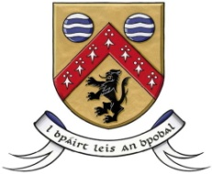

Laois County Council

In partnership with

Laois Public Participation Network

Community & Voluntary Awards 2017
Nomination Form

This form should be used to nominate a Group/Club/Organisation
Groups/Clubs/Organisations can nominate themselves

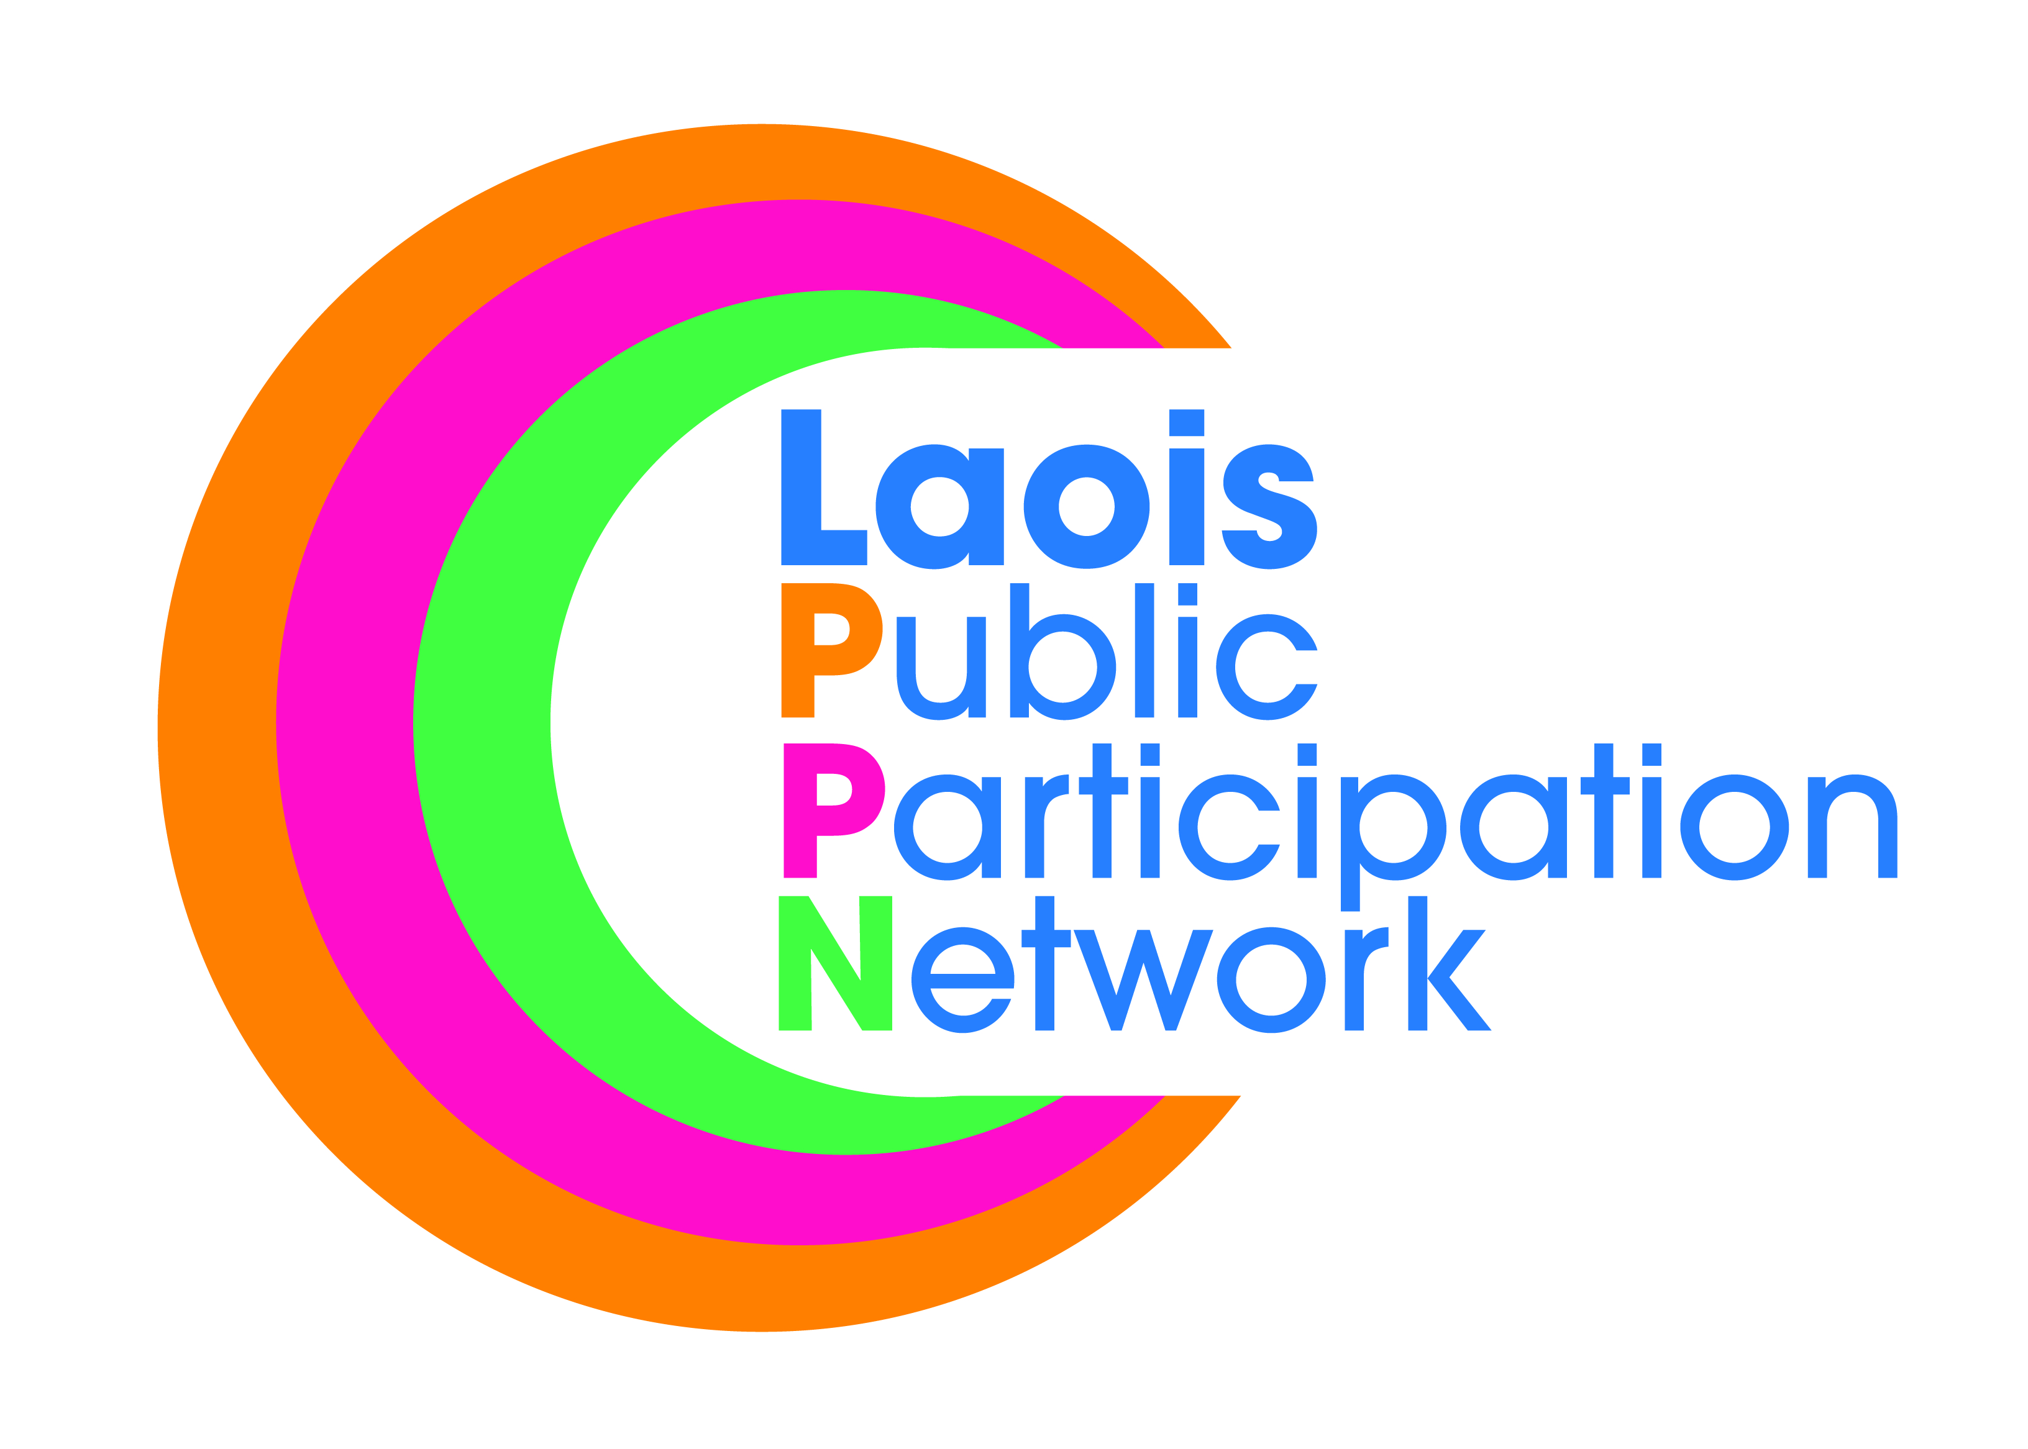

N.B! Before completing this form, please read the accompanying terms & conditions and judging criteria

Under which Category do wish you to nominate a Group/Club/Organisation:
Application Form
Please tick one only
Arts, Culture &Heritage – Sponsored by
This award recognises Groups/Organisations who enhance their local areas, by conserving, protecting and promoting the Arts, Culture and Heritage of their local community through collective creative activities. Examples include: Drama, Music, Literature, Arts, Festivals, Conservation, and Heritage.

Healthy & Active Community– Sponsored by
The award recognises Groups/Organisations that encourage a healthy community by promoting positive environments and initiatives that support and encourage physical activity, healthy lifestyles and a sense of community connection. Examples include: Walking/Hiking Clubs, indoor and outdoor activities and Physical Activity Programmes

Children & Youth – Sponsored by
This award recognises Groups/Organisations which have a positive impact on the lives of children. Examples include: Community Childcare Services/Facilities, Youth Groups, Sports Clubs, homework clubs, also those who work with children with additional needs and disabilities.

Environment – Sponsored by
This award recognises Groups/Organisations working to enhance and develop their community and/or their locality from a social or environmental perspective and create a sense of pride and inclusivity in their area. Types of groups include: Community Development, Tidy Towns/Villages, Environmental, Enterprise & Youth, Tourism, Housing estates.

Social Inclusion – Sponsored by
This award recognises Groups/Organisations that actively work in a supportive role in their communities and whose aim is to minimise social exclusion and/or help to improve the quality of life for socially excluded groups. Examples include; Working with the elderly, People with Disabilities, Ethnic Minority, Travelling Community, Young people in transition and the Homeless.

Age Friendly – Sponsored by
This award recognises Groups/Organisations who help to create an inclusive, equitable society in which older people can live full, active, valued and healthy lives. Examples include: active retirement, senior citizen clubs, meals on wheels, mens shed, befriending services etc.

I wish to nominate the following Group/Club/Organisation for a Community & Voluntary Award:

Name of Group/Club/ Organisation
Address

Contact Name
Phone No.
(daytime contact)
Email address for contact | 

- Is the Group/Organisation a member of Laois PPN? Yes NO

- No. of Voluntary workers No. of Paid Workers

- What year was your Group/Club/Organisation founded?

- How is the Group funded? _______________________________________________________________
___________________________________________________________________________________

NOMINATOR: (the person or group making the nomination – please ensure you read the terms & conditions regarding this section!)
Your Name
(either an individual or a group)
Your Address
Phone No. (daytime contact)
Email address for contact | 

State the reasons why the group deserves the award?
- ____________________________________________________________________________________
- ____________________________________________________________________________________
- ____________________________________________________________________________________

Please highlight the current/recent activities and achievements of the nominated group/organisation?
(You can use photos and/or separate pages to illustrate these if you prefer)
__________________________________________________________________________________________________________________________________________________________________________________________________________________________________________________________________________________________________________________________________________________________________________________________________________________________________________________________________
__________________________________________________________________________________________

How does the group/organisation benefit the community?
__________________________________________________________________________________________________________________________________________________________________________________________________________________________________________________________________________________________________________________________________________________________________________________________________________________________________________________________________

Does your group meet the needs of any of the following target groups: (please tick relevant)

Older People |  | Travelling Community |  | Minority Groups |  | Ethnic Groups
People with Disabilities |  | Women, Youth & Children |  | People living in rural areas

What are the future plans of the Group/Organisation?
________________________________________________________________________________________________________________________________________________________________________________________________________________________________________________________________________________________________________________________________________________________________________

TERMS & CONDITIONS:
- The group/club/organisation must be well established.
- The group/club/organisation must be registered with Laois Public Participation Network.
- Please note that it is not necessary that the person/group making the nomination is associated with, or a member of, the nominated group.
- The group should not be in receipt of regular State funding, e.g., regular grant aid. Should the group have received a once-off grant for a particular item/project, this should be disclosed and will be judged accordingly.
- The nominated group must have set out what they are about, highlighting their current/recent activities and the impact that all of their activities have on the local and wider community including, if appropriate, their level of participation locally and their level of volunteerism.
- The nominated group must have set out what their plans are for the future, based on their commitment to making a difference in the community.
- Photos and/or accompanying documentation will be accepted, in fact encouraged, as part of the nominated application. Please send in copies only of photos, certificates, etc as originals may not be returned.
JUDGING CRITERIA
Groups will be judged by the Adjudication Panel based on the following criteria:
- Contribution of the group to the community
- How representative the group is of the community
- Level of voluntary involvement and participation
- How well a groups services and/or activities are planned and delivered, and the use of innovative approaches
- Positive impact of the work of the group on the local and wider community
- Positive impact the work has had on the target category, i.e., arts, community services & support, sports & recreation, etc.
- Use of inclusive working methods, e.g., reaching out to ensure that those who most need to actually get involved/benefit from inclusion.
- Future benefits to the community
Completed application should be marked
“Community & Voluntary Award 2017 Nomination”
and sent by 5pm on Friday 21st July, 2017 to:
Ms. Geraldine Delaney
Community Development Section,
Laois County Council,
County Hall, Portlaoise
For further assistance and queries, please contact (057) 86 64107 or email gdelaney@laoiscoco.ie

